Supply Chain Network
Design and Implementation Documentation
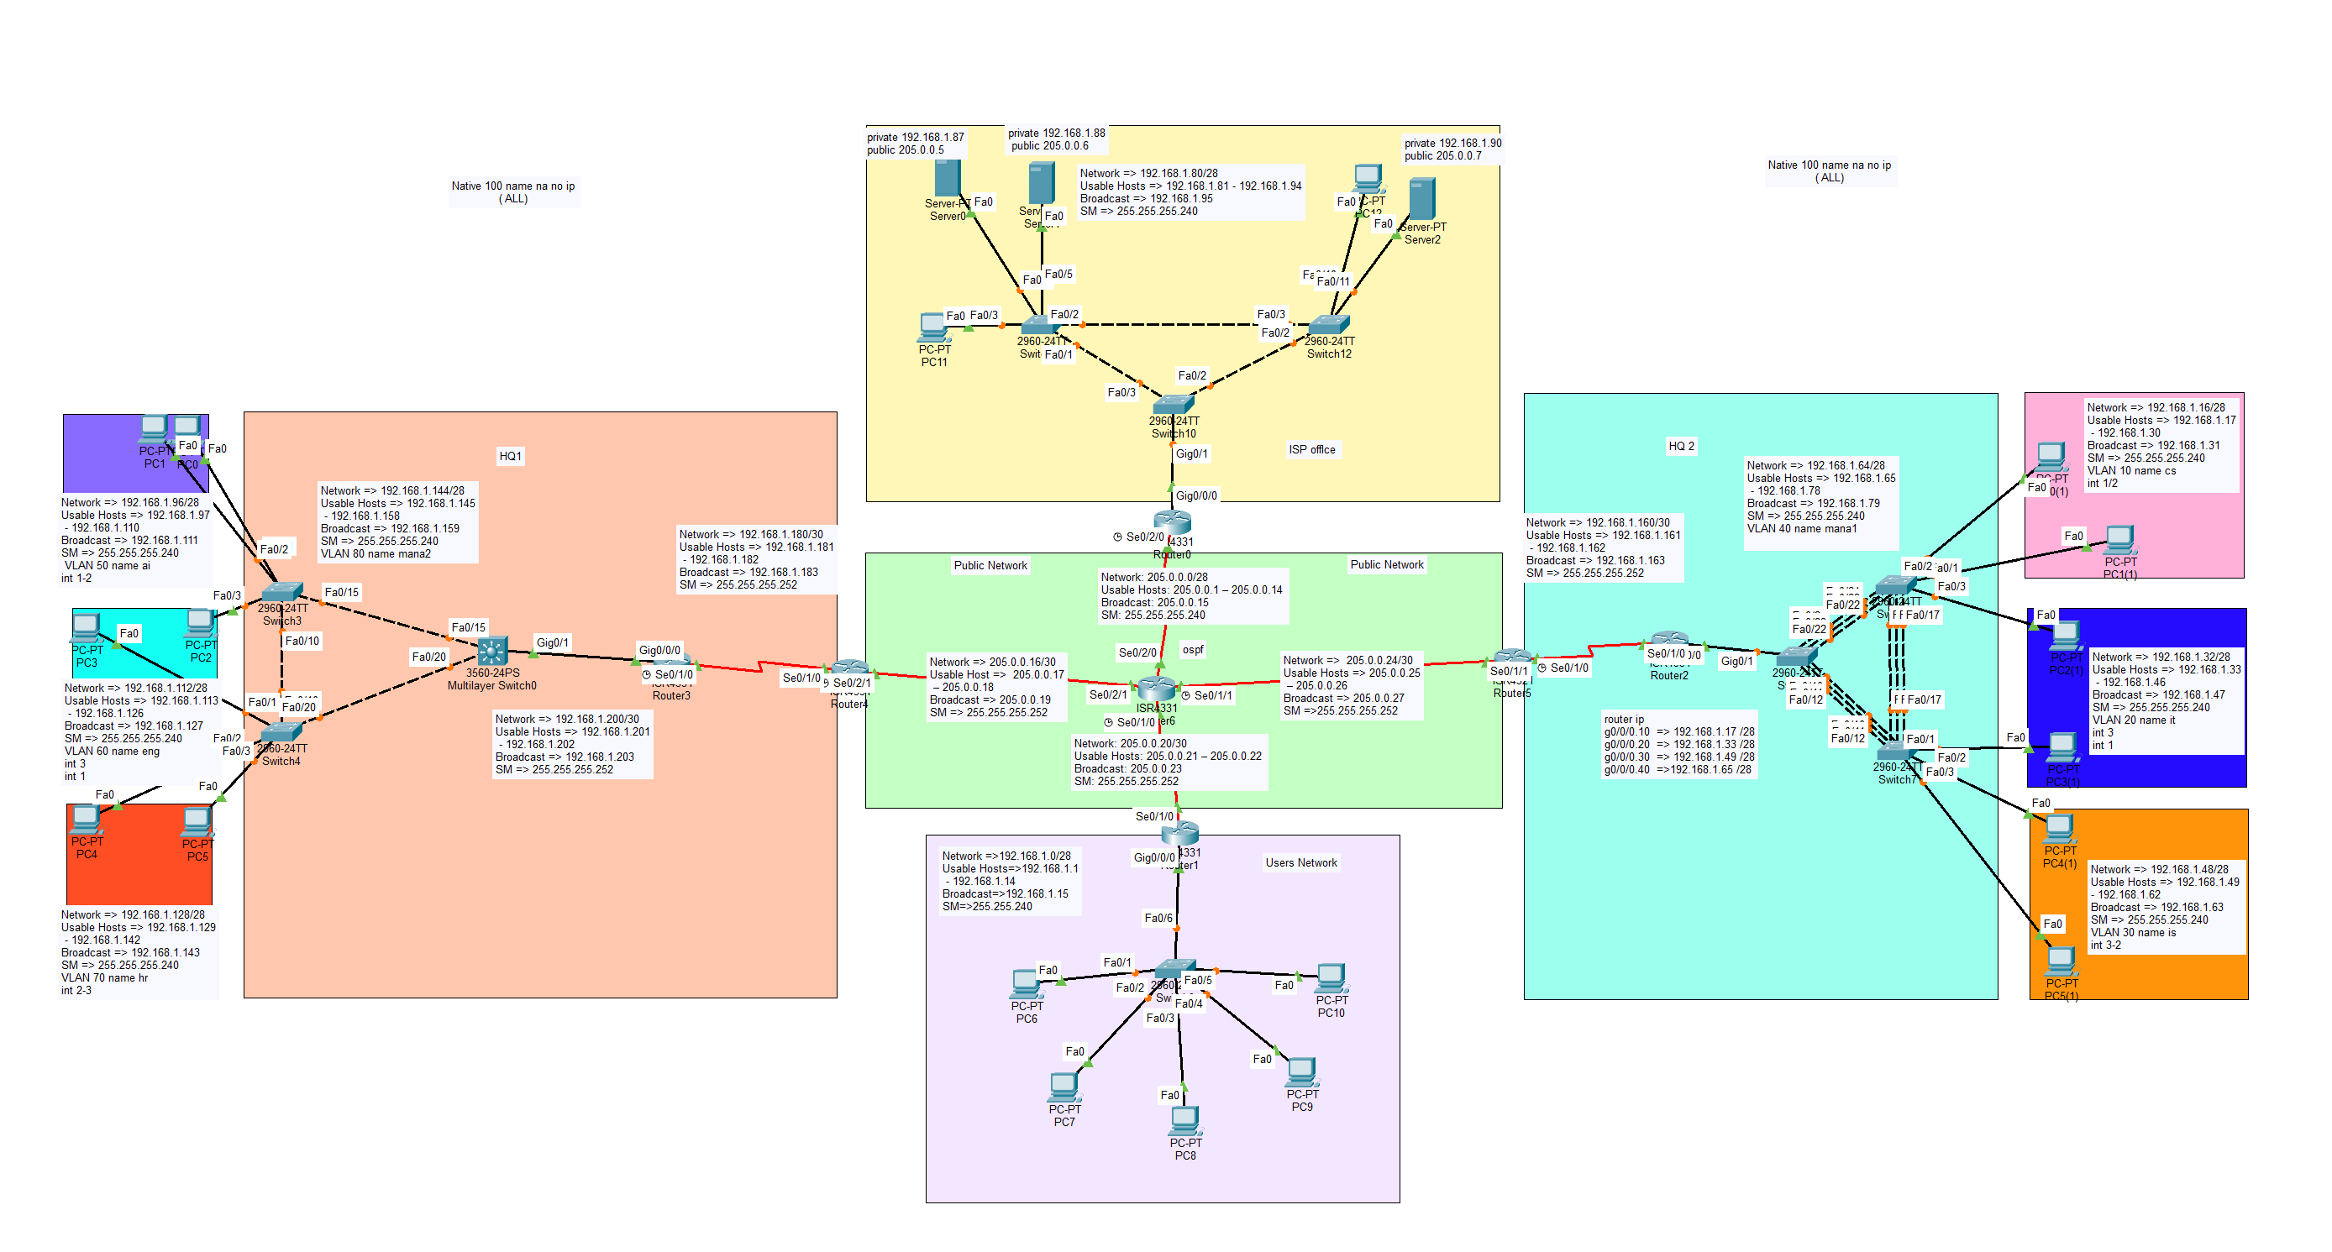
Prepared by: Mohamed Ahmed Elsayad
Supervised by: Eng. Saher Waleed
Tool Used: Cisco Packet Tracer
Date: September 8, 2026

Project Contents
1. Project description and overall network design.
2. Subnetting, and IP addressing assigned to end devices (static and dynamic) and network devices.
3. EtherChannel configuration between switches.
4. VLAN creation, including access ports, trunk ports, and management VLAN configuration on switches.
5. Routing configuration between network devices, including OSPF, default static routes, and host routing.
6. Static NAT configuration.
7. PAT (Port Address Translation) configuration.
8. Encrypted passwords for device security.
9. Remote access configuration using Telnet and SSH.
10. Troubleshooting of the network.

Project Overview
This project presents the design and implementation of a Supply Chain Network, built entirely on Cisco Packet Tracer to model a realistic enterprise infrastructure. The topology is made up of 17 different networks, combining regular LAN subnets with several point-to-point links, and connects multiple sites: two headquarters (HQ1 on the left and HQ2 on the right), a central Public Network core, an ISP office at the top, and a Users Network at the bottom.
The design includes a total of 8 VLANs, split evenly between the two headquarters: four VLANs on HQ1 (AI, ENG, HR, and MANA2) and four VLANs on HQ2 (CS, IT, IS, and MANA1). In addition, a dedicated Management VLAN (native VLAN 100, configured with no IP address) was created on both the left and right sides for secure switch management traffic. On top of this, six point-to-point networks were used to interconnect the devices: two within HQ1, one within HQ2, three within the central Public Network core, and one point-to-point link at the top site and one at the bottom site, connecting the ISP office and the Users Network to the core.
Every end device and network device (routers and switches) was assigned an IP address, using a mix of static and dynamic (DHCP) addressing for end devices. Switch ports were configured as trunk or access as appropriate, with the native VLAN set to 100 across all trunk links, and EtherChannel was configured between switches to provide link redundancy and load balancing. A multilayer switch was also configured to support inter-VLAN routing and DHCP services.
Routing between sites was implemented using OSPF as the dynamic routing protocol, supported by default static routes and host routes where needed. Passive-interface was configured on the top and bottom routers (ISP office and Users Network) to prevent unnecessary OSPF advertisements on their end-facing interfaces.
The top, bottom, left, and right networks are all private networks, while the central Public Network core, along with the public-facing servers at the top site, represents the public zone. Static NAT was configured on the top router to translate its private servers to public addresses, while PAT (overload) was configured on the top, bottom, left, and right routers so that traffic leaving these private networks is translated to a public address before reaching the core. As a result, a private network cannot directly ping another private network; it can only reach the public zone, while the private and public addresses within the central core can ping each other directly.
Finally, the network was secured by enabling encrypted passwords on all devices and configuring remote management access through both Telnet and SSH.

Subnetting Plan
The network address space was divided into 17 subnets in total: 10 LAN subnets using a /28 mask (16 addresses, 14 usable hosts each), 6 point-to-point (P2P) links using a /30 mask (4 addresses, 2 usable hosts each), and 1 additional /28 LAN subnet for the public network. The full breakdown is shown below.
# | Type | Network | Usable Hosts | Broadcast | Subnet Mask
1 | LAN /28 | 192.168.1.0/28 | 192.168.1.1 - 192.168.1.14 | 192.168.1.15 | 255.255.255.240
2 | LAN /28 | 192.168.1.16/28 | 192.168.1.17 - 192.168.1.30 | 192.168.1.31 | 255.255.255.240
3 | LAN /28 | 192.168.1.32/28 | 192.168.1.33 - 192.168.1.46 | 192.168.1.47 | 255.255.255.240
4 | LAN /28 | 192.168.1.48/28 | 192.168.1.49 - 192.168.1.62 | 192.168.1.63 | 255.255.255.240
5 | LAN /28 | 192.168.1.64/28 | 192.168.1.65 - 192.168.1.78 | 192.168.1.79 | 255.255.255.240
6 | LAN /28 | 192.168.1.80/28 | 192.168.1.81 - 192.168.1.94 | 192.168.1.95 | 255.255.255.240
7 | LAN /28 | 192.168.1.96/28 | 192.168.1.97 - 192.168.1.110 | 192.168.1.111 | 255.255.255.240
8 | LAN /28 | 192.168.1.112/28 | 192.168.1.113 - 192.168.1.126 | 192.168.1.127 | 255.255.255.240
9 | LAN /28 | 192.168.1.128/28 | 192.168.1.129 - 192.168.1.142 | 192.168.1.143 | 255.255.255.240
10 | LAN /28 | 192.168.1.144/28 | 192.168.1.145 - 192.168.1.158 | 192.168.1.159 | 255.255.255.240
11 | P2P /30 | 192.168.1.160/30 | 192.168.1.161 - 192.168.1.162 | 192.168.1.163 | 255.255.255.252
12 | P2P /30 | 192.168.1.180/30 | 192.168.1.181 - 192.168.1.182 | 192.168.1.183 | 255.255.255.252
13 | LAN /28 | 205.0.0.0/28 | 205.0.0.1 - 205.0.0.14 | 205.0.0.15 | 255.255.255.240
14 | P2P /30 | 205.0.0.16/30 | 205.0.0.17 - 205.0.0.18 | 205.0.0.19 | 255.255.255.252
15 | P2P /30 | 205.0.0.20/30 | 205.0.0.21 - 205.0.0.22 | 205.0.0.23 | 255.255.255.252
16 | P2P /30 | 205.0.0.24/30 | 205.0.0.25 - 205.0.0.26 | 205.0.0.27 | 255.255.255.252
17 | P2P /30 | 192.168.1.200/30 | 192.168.1.201 - 192.168.1.202 | 192.168.1.203 | 255.255.255.252

IP Addressing
Every end device and network device in the topology was assigned an IPv4 address based on the subnetting plan. End devices were configured using a mix of Static and Dynamic (DHCP) addressing, while all network devices (router and switch interfaces) were configured with static IP addresses.
Static IP Addressing
For end devices configured with a static address, the IPv4 address, subnet mask, default gateway, and DNS server were entered manually, as shown in the example below.
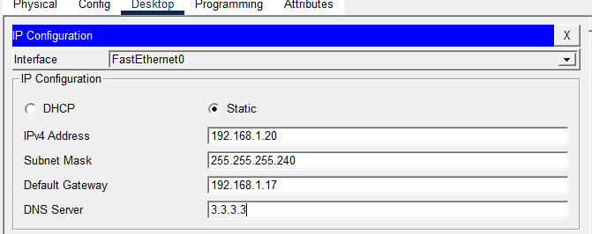
Dynamic IP Addressing (DHCP)
For end devices configured to obtain their address automatically, the DHCP option was selected, and the device received its IPv4 address, subnet mask, default gateway, and DNS server automatically from the DHCP service, as shown below.
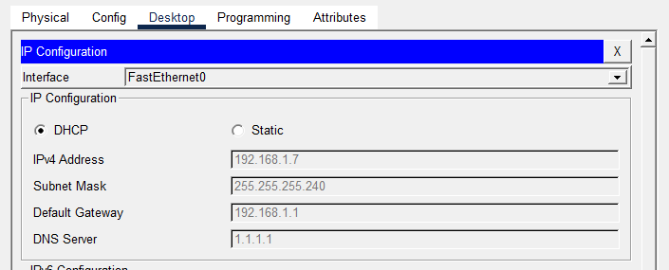
This address was handed out by a DHCP pool configured on the router, which included the network, default gateway, and DNS server, with the router and switch management addresses excluded from the pool. Example configuration:
Router(config-if)#exit
Router(config)#ip dhcp pool user
Router(dhcp-config)#network 192.168.1.0 255.255.255.240
Router(dhcp-config)#default-router 192.168.1.1
Router(dhcp-config)#dns-server 1.1.1.1
Router(dhcp-config)#exit
Router(config)#ip dhcp excluded-address 192.168.1.1 192.168.1.2

EtherChannel Configuration
EtherChannel was configured between the core switches (S1, S2, and S3) using LACP (Link Aggregation Control Protocol) to bundle multiple physical links into logical port-channels, providing increased bandwidth and link redundancy between switches. The table below summarizes the output of the "show etherchannel summary" command on each switch.
Switch | Group | Port-Channel | Protocol | Member Ports
S1 | 1 | Po1 (SU) | LACP | Fa0/22(P), Fa0/23(P), Fa0/24(P)
S1 | 2 | Po2 (SU) | LACP | Fa0/15(P), Fa0/16(P), Fa0/17(P)
S2 | 2 | Po2 (SU) | LACP | Fa0/15(P), Fa0/16(P), Fa0/17(P)
S2 | 3 | Po3 (SU) | LACP | Fa0/10(P), Fa0/11(P), Fa0/12(P)
S3 | 1 | Po1 (SU) | LACP | Fa0/22(P), Fa0/23(P), Fa0/24(P)
S3 | 3 | Po3 (SU) | LACP | Fa0/10(P), Fa0/11(P), Fa0/12(P)
Each port-channel shows a status of (SU), meaning the bundle is Layer 2 and up, with all member ports negotiated successfully using LACP, shown as (P). Based on the matching group numbers, S1 and S2 are linked through Po2, S1 and S3 are linked through Po1, and S2 and S3 are linked through Po3, forming a fully redundant triangle between the three switches.

VLAN Configuration
1. VLAN Creation
Eight VLANs were created across the switches, plus a dedicated native VLAN 100 used for switch management traffic with no IP address assigned. Example of VLAN creation on switch S1:
Switch(config)#hostname S1
S1(config)#vlan 10
S1(config-vlan)#name cs
S1(config-vlan)#vlan 20
S1(config-vlan)#name it
S1(config-vlan)#vlan 30
S1(config-vlan)#name is
S1(config-vlan)#vlan 40
S1(config-vlan)#name mana1
S1(config-vlan)#vlan 100
S1(config-vlan)#name na
S1(config-vlan)#end
2. Access Port Configuration
Switch ports connected to end devices were configured in access mode and assigned to their corresponding VLAN. Example of access port configuration on switch S1:
S1(config)#int range f0/1-2
S1(config-if-range)#switchport mode access
S1(config-if-range)#switchport access vlan 10
S1(config-if-range)#exit
S1(config)#int range f0/3
S1(config-if-range)#switchport mode access
S1(config-if-range)#switchport access vlan 20
S1(config-if-range)#exit
3. Trunk Port Configuration
Links between switches were configured in trunk mode to carry traffic for multiple VLANs, with the native VLAN set to 100 and the allowed VLAN list restricted to the VLANs in use. Example of trunk port configuration on switch S3:
S3(config)#int g0/1
S3(config-if)#switchport mode trunk
S3(config-if)#switchport trunk native vlan 100
S3(config-if)#switchport trunk allowed vlan 10,20,30,40,100
S3(config-if)#end

Routing Configuration
Routing between sites was implemented using OSPF (area 0) as the dynamic routing protocol, combined with a default static route on each edge router pointing out to the ISP, and passive-interface configured on the LAN-facing interfaces of the edge routers to prevent unnecessary OSPF advertisements toward end devices.
ISP Office Router (Top Site)
The passive-interface command was applied on the LAN-facing interface to stop OSPF hello packets from being sent toward the end devices, while a default static route was configured toward the core network.
router ospf 1
log-adjacency-changes
passive-interface GigabitEthernet0/0/0
!
ip classless
ip route 0.0.0.0 0.0.0.0 Serial0/1/0
HQ2 Edge Router
This router advertises its directly connected point-to-point network into OSPF and uses default-information originate to inject its own default route into the OSPF domain, alongside a locally configured default static route toward the core.
router ospf 1
log-adjacency-changes
network 192.168.1.160 0.0.0.3 area 0
default-information originate
!
ip classless
ip route 0.0.0.0 0.0.0.0 Serial0/1/1
HQ2 Core Router
This router advertises all of the HQ2 VLAN subnets (CS, IT, IS, and the point-to-point link) into OSPF area 0, together with a default static route toward the core.
router ospf 1
log-adjacency-changes
network 192.168.1.16 0.0.0.15 area 0
network 192.168.1.32 0.0.0.15 area 0
network 192.168.1.48 0.0.0.15 area 0
network 192.168.1.160 0.0.0.3 area 0
network 192.168.1.64 0.0.0.15 area 0
!
ip classless
ip route 0.0.0.0 0.0.0.0 Serial0/1/0
Host Routing
In addition to OSPF and the default static routes, host routes (/32) were configured on the ISP office router to direct traffic for each individual public server address out toward the core network.
ip classless
ip route 205.0.0.5 255.255.255.255 Serial0/2/0
ip route 205.0.0.6 255.255.255.255 Serial0/2/0
ip route 205.0.0.7 255.255.255.255 Serial0/2/0
Static NAT Configuration
Static NAT was configured on the ISP office router (R-ISP) to permanently map each private server address to a dedicated public address, allowing the servers to be reached from the public network. The inside (LAN-facing) and outside (WAN-facing) interfaces were marked accordingly for NAT to take effect.
R-ISP#conf t
R-ISP(config)#ip nat inside source static 192.168.1.87 205.0.0.5
R-ISP(config)#ip nat inside source static 192.168.1.88 205.0.0.6
R-ISP(config)#ip nat inside source static 192.168.1.90 205.0.0.7
R-ISP(config)#int g0/0/0
R-ISP(config-if)#ip nat inside
R-ISP(config-if)#exit
R-ISP(config)#int se0/2/0
R-ISP(config-if)#ip nat outside
R-ISP(config-if)#exit
The static mappings were verified using the "show ip nat translations" command, which shows each private server address permanently bound to its public address, along with active ICMP translations captured during ping tests from outside the network:
Pro | Inside Global | Inside Local | Outside Local | Outside Global
icmp | 205.0.0.5:10 | 192.168.1.87:10 | 205.0.0.18:10 | 205.0.0.18:10
icmp | 205.0.0.5:11 | 192.168.1.87:11 | 205.0.0.18:11 | 205.0.0.18:11
icmp | 205.0.0.5:12 | 192.168.1.87:12 | 205.0.0.18:12 | 205.0.0.18:12
icmp | 205.0.0.5:9 | 192.168.1.87:9 | 205.0.0.18:9 | 205.0.0.18:9
--- | 205.0.0.5 | 192.168.1.87 | --- | ---
--- | 205.0.0.6 | 192.168.1.88 | --- | ---
--- | 205.0.0.7 | 192.168.1.90 | --- | ---
PAT Configuration
PAT (overload) was configured on the HQ1 and HQ2 edge routers so that all private hosts on their side share a single public/outside address when reaching the core network. An access list was used on each router to define which private subnets are allowed to be translated, and the inside/outside interfaces were marked accordingly.
R-HQ1
R-HQ1(config)#ip nat inside source list 1 int se0/2/1 overload
R-HQ1(config)#access-list 1 permit 192.168.1.96 0.0.0.15
R-HQ1(config)#access-list 1 permit 192.168.1.112 0.0.0.15
R-HQ1(config)#access-list 1 permit 192.168.1.128 0.0.0.15
R-HQ1(config)#access-list 1 permit 192.168.1.144 0.0.0.15
R-HQ1(config)#access-list 1 permit 192.168.1.180 0.0.0.3
R-HQ1(config)#int se0/1/0
R-HQ1(config-if)#ip nat inside
R-HQ1(config-if)#exit
R-HQ1(config)#int se0/2/1
R-HQ1(config-if)#ip nat outside
R-HQ1(config-if)#exit
The PAT translation was verified on R-HQ1 using "show ip nat translations", confirming that multiple private hosts are translated to the single outside address 205.0.0.18 with different port numbers:
Pro | Inside Global | Inside Local | Outside Local | Outside Global
icmp | 205.0.0.18:10 | 192.168.1.115:10 | 205.0.0.6:10 | 205.0.0.6:10
icmp | 205.0.0.18:11 | 192.168.1.115:11 | 205.0.0.6:11 | 205.0.0.6:11
icmp | 205.0.0.18:12 | 192.168.1.115:12 | 205.0.0.6:12 | 205.0.0.6:12
icmp | 205.0.0.18:13 | 192.168.1.115:13 | 205.0.0.1:13 | 205.0.0.1:13
icmp | 205.0.0.18:14 | 192.168.1.115:14 | 205.0.0.1:14 | 205.0.0.1:14
icmp | 205.0.0.18:15 | 192.168.1.115:15 | 205.0.0.1:15 | 205.0.0.1:15
icmp | 205.0.0.18:16 | 192.168.1.115:16 | 205.0.0.1:16 | 205.0.0.1:16
icmp | 205.0.0.18:17 | 192.168.1.115:17 | 205.0.0.17:17 | 205.0.0.17:17
icmp | 205.0.0.18:18 | 192.168.1.115:18 | 205.0.0.17:18 | 205.0.0.17:18
icmp | 205.0.0.18:19 | 192.168.1.115:19 | 205.0.0.17:19 | 205.0.0.17:19
icmp | 205.0.0.18:20 | 192.168.1.115:20 | 205.0.0.17:20 | 205.0.0.17:20
icmp | 205.0.0.18:21 | 192.168.1.115:21 | 205.0.0.17:21 | 205.0.0.17:21
icmp | 205.0.0.18:22 | 192.168.1.115:22 | 205.0.0.17:22 | 205.0.0.17:22
icmp | 205.0.0.18:23 | 192.168.1.115:23 | 205.0.0.17:23 | 205.0.0.17:23
icmp | 205.0.0.18:24 | 192.168.1.115:24 | 205.0.0.17:24 | 205.0.0.17:24
icmp | 205.0.0.18:9 | 192.168.1.115:9 | 205.0.0.6:9 | 205.0.0.6:9
R-HQ2
R-HQ2(config)#ip nat inside source list 2 int se0/1/1 overload
R-HQ2(config)#access-list 2 permit 192.168.1.16 0.0.0.15
R-HQ2(config)#access-list 2 permit 192.168.1.32 0.0.0.15
R-HQ2(config)#access-list 2 permit 192.168.1.48 0.0.0.15
R-HQ2(config)#access-list 2 permit 192.168.1.64 0.0.0.15
R-HQ2(config)#access-list 2 permit 192.168.1.160 0.0.0.3
R-HQ2(config)#int se0/1/0
R-HQ2(config-if)#ip nat inside
R-HQ2(config-if)#exit
R-HQ2(config)#int se0/1/1
R-HQ2(config-if)#ip nat outside
R-HQ2(config-if)#exit
Device Security - Encrypted Passwords
Every device in the topology was secured with encrypted passwords. The enable secret command was used to set an encrypted privileged EXEC password, a password was set on the console line, and the service password-encryption command was applied so that all plaintext passwords stored in the configuration are automatically encrypted. Example configuration on switch S2:
S2(config)#enable secret cisco
S2(config)#line console 0
S2(config-line)#pass cisco
S2(config-line)#login
S2(config-line)#exit
S2(config)#service password-encryption
The running configuration on R-Center confirms that the passwords are stored in encrypted form rather than plain text, using type 7 encryption for the console password and type 5 (MD5) hashing for the enable secret:
line con 0
password 7 0822455D0A16
login
!
enable secret 5 $1$mERr$hx5rVt7rPNoS4wqbXKX7m0
Console login was verified on R-Center, prompting for the configured password before granting privileged EXEC access:
Password:
R-Center>en
Password:
R-Center#
Remote Access - SSH Configuration
SSH was configured for secure remote management of the switches, replacing plaintext Telnet access. This required setting a domain name, generating an RSA key pair, creating a local user account, and restricting the VTY lines to use local login. Example configuration on switch S2:
S2(config)#ip domain name cisco.com
S2(config)#crypto key generate rsa
How many bits in the modulus [512]: 1024
S2(config)#username cisco secret cisco
S2(config)#line vty 0 5
S2(config-line)#login local
S2(config-line)#transport input all
S2(config-line)#exit
SSH access was verified from a PC command prompt by connecting to the routers using their public and private addresses, confirming that remote login succeeds with the configured credentials:
C:\>ssh -l cisco 205.0.0.2
Password:
R-ISP>en
Password:
R-ISP#exit
[Connection to 205.0.0.2 closed by foreign host]
C:\>ssh -l cisco 192.168.1.201
Password:
R1>en
Password:
R1#exit
[Connection to 192.168.1.201 closed by foreign host]
Troubleshooting
The following checklist summarizes the commands used to validate the network and the expected result for each functional area.
Area | Command(s) | Expected Result
Physical topology | show cdp neighbors | Matches documented physical connections
Interfaces | show ip interface brief | All expected interfaces up/up
VLANs & trunks | show vlan brief  show interfaces trunk | Correct VLAN membership; trunks forwarding
EtherChannel | show etherchannel summary | Bundled ports shown as (P); channel shown as (SU)
Inter-VLAN routing | show ip route (MLS0 / Router2) | All local VLAN subnets listed as connected
OSPF (core only) | show ip ospf neighbor  show ip route ospf | Expected neighbours in FULL state
Static routing (edge routers) | show ip route static | Default route present with correct next-hop
NAT / PAT | show ip nat translations  show ip nat statistics | Static entries always present; dynamic entries populate under traffic
DHCP (Router1) | show ip dhcp binding | Clients leased addresses within the configured pool
End-to-end | ping <translated address> | 100% success rate between any two sites
Conclusion
This project successfully delivered a complete, working design for the Supply Chain Network, taking it from initial subnetting and IP addressing all the way through to a secured, fully routed, and verified infrastructure. Each stage of the network, from VLAN segmentation and EtherChannel at the access layer, to OSPF routing and NAT/PAT translation at the network edge, was implemented and tested to confirm that it behaves as intended.
Beyond connectivity, the project also placed emphasis on security and manageability, through encrypted passwords, restricted SSH-based remote access, and a structured management VLAN, reflecting practices that are expected in real enterprise environments. The troubleshooting checklist further ensured that every functional area of the network, from the physical layer up to end-to-end reachability, could be verified and revalidated with confidence.
Overall, this project provided valuable hands-on experience in designing, implementing, and securing an enterprise-scale network using Cisco Packet Tracer, and reinforced core networking concepts that form the foundation for real-world network administration and support roles.

